

JAVA PROJECT REPORT ON
Online Quiz Examination System with Automated Result Evaluation

Submitted by
SHALINI S
25BCS053

Under the Guidance of
DR.S.BOOPALAN SUNDARAMOORTHY
Technical Head
Technical Department, KG College of Arts and Science

Academic Year: 2025 – 2026
APRIL 2026
Semester: II

01

DECLARATION
I hereby declare that the project entitled “ONLINE QUIZ EXAMINATION SYSTEM WITH AUTOMATED RESULT EVALUATION ” submitted in partial fulfillment of the requirements for the course JAVA PROGRAMMING is a record of my original work carried out under the guidance of DR.S.BOOPALAN SUNDARAMOORTHY, Technical Trainer, Technical Department, KG College of Arts and Science.
I further declare that this project has not been submitted previously, either in part or in full, for the award of any degree, diploma, or other similar title, at this or any other institution.
I have acknowledged all sources of information used in this project wherever applicable.

April 2026
Coimbatore

SHALINI S

02

CERTIFICATE
This is to certify that the project entitled “ONLINE QUIZ EXAMINATION SYSTEM WITH AUTOMATED RESULT EVALUATION ” is a bona fide work carried out by SHALINI S,[1-A/2026-2028], computer science, KG College of Arts & Science, in partial fulfillment of the requirements for the course JAVA PROGRAMMING.
This project has been completed under my supervision and guidance during the academic period April 2026.

Place: Coimbatore
Date: 10/04/2026

Submitted for the Viva-Voce Examination held on :10/04/2026

Guide: Head of the Department
(Technical Head, KGCAS) (Technical Head, KGCAS)
--------------------------- ----------------------

03

TABLE OF CONTENTS
S. No. | Topics | Page. No.
1 | Introduction | 06-08
1.1 | Objective | 07
1.2 | Overview | 07
1.3 | Features | 08
2 | Program Analysis | 09-10
2.1 | Problem Definition | 09
2.2 | Project Overview | 09
2.3 | Scopes and Limitations | 10
3 | System Design | 11-13
3.1 | Modules | 11
4 | Methodology | 13-15
4.1 | System Design | 13
4.2 | Technology Selection | 13
4.3 | Implementation | 13
4.4 | Testing and Validation | 14
4.5 | Deployment | 14
4.6 | Algorithm | 14
4.7 | Flowchart | 16
5 | Source Code | 17
6 | Input and Output Screens | 20
7 | Discussion and Conclusion | 20
7.1 | Discussion | 20
7.2 | Conclusion | 20
8 | References | 22

04

ABSTRACT
The Online Quiz Examination System with Automated Result Evaluation is a modern web-based platform designed to simplify and enhance the process of conducting examinations and evaluating student performance. With the rapid growth of digital technologies and the increasing demand for remote learning solutions, this system provides an efficient, reliable, and scalable alternative to traditional paper-based examinations.
The system allows administrators and instructors to create, manage, and organize quizzes through a centralized interface. They can design question papers using various formats such as multiple-choice questions, true/false, fill-in-the-blanks, and short-answer questions. Questions can be stored in a structured question bank, categorized by subject, topic, and difficulty level, enabling easy reuse and randomization for different exams. This ensures diversity in question sets and reduces the chances of malpractice.
Students can securely log in to the system and attempt quizzes within a specified time frame. The platform supports features such as timed exams, automatic submission upon time expiration, and randomized question order to maintain fairness and integrity. A user-friendly interface ensures that students can navigate the system easily, even with minimal technical knowledge.
One of the most significant features of the system is its automated result evaluation capability. Objective-type questions are evaluated instantly upon submission, providing immediate results to students. For certain subjective responses, predefined answer matching techniques can be used to assist in evaluation. This automation minimizes human errors, reduces evaluation time, and ensures consistency in grading.
The system also includes advanced performance analysis tools that generate detailed reports for both students and instructors. These reports may include individual scores, topic-wise performance, accuracy rates, and comparative analysis with peers. Graphical representations such as charts and leaderboards help in better understanding of student progress and identifying areas for improvement.
Security is a critical aspect of the system. It incorporates user authentication, secure data storage, and controlled access mechanisms to protect sensitive information. Additional measures such as question shuffling, restricted navigation, and activity monitoring help prevent cheating and ensure the credibility of the examination process.
Furthermore, the system is designed to be scalable and accessible across multiple devices, including desktops, tablets, and smartphones. It can be deployed on cloud infrastructure to support a large number of concurrent users without performance issues. Notifications and alerts keep users informed about upcoming exams, deadlines, and results, improving overall communication.
05

- INTRODUCTION
The Online Quiz Examination System with Automated Result Evaluation is a web-based application developed to enhance and simplify the traditional examination process. In recent years, the integration of digital technology in education has increased significantly, creating a demand for efficient and reliable online assessment systems. This system provides a platform where administrators and instructors can easily create, manage, and schedule quizzes, while students can participate in exams from any location with internet access.
The system supports multiple types of questions, including multiple-choice, true/false, and short-answer formats, allowing flexibility in designing assessments. It also includes features such as time limits, question randomization, and secure login to ensure fairness and integrity during examinations. One of the key advantages of this system is its automated result evaluation, which instantly calculates scores upon submission, reducing manual effort and minimizing errors.
Additionally, the system generates detailed performance reports and analytics to help track student progress and identify strengths and weaknesses. Overall, it improves efficiency, saves time, and provides a reliable solution for modern educational assessment needs.

06
1.1 Objective
To develop an online system for conducting quizzes efficiently with automated result evaluation, ensuring accuracy, reducing manual effort, providing instant feedback, enhancing accessibility, maintaining exam security, and generating performance reports for effective student assessment and progress tracking.
The specific objectives of this project are:
- To design and develop a secure and user-friendly online quiz platform.
- To enable easy creation and management of quizzes and question banks.
- To support multiple question formats for flexible assessment.
- To implement automated result evaluation for quick and accurate grading.
- To provide instant feedback and detailed performance reports.
- To ensure fairness through timed tests and question randomization.
- To reduce manual workload and improve efficiency in examinations.
1.2 Overview
The Online Quiz Examination System with Automated Result Evaluation is a comprehensive web-based solution designed to conduct, manage, and evaluate examinations digitally. It replaces traditional paper-based methods with an efficient and automated system that simplifies the entire examination process for both administrators and students.
The system consists of different modules, including user management, quiz creation, question bank management, exam conduction, and result evaluation. Administrators and instructors can create quizzes using various question types, set time limits, and configure exam rules. Questions are stored in a centralized database, allowing easy organization and reuse.
Students can log in securely and take quizzes online within a specified time. The system ensures fairness through features like randomized questions and automatic submission when time expires. Once the exam is completed, the automated evaluation system instantly calculates scores and generates results, eliminating manual correction.
Additionally, the system provides detailed performance analysis, including scores, accuracy, and progress reports. It is accessible from multiple devices and designed to handle multiple users simultaneously. Overall, the system offers a reliable, time-saving, and scalable solution for modern examination needs.

07
1.3 Features
1.User Authentication and Role Management
  - Secure login for administrators, instructors, and students.
  - Role-based access to control functionalities for each user type.
- Quiz Creation and Management
  - Create, edit, and delete quizzes easily.
  - Support for multiple question types: multiple-choice, true/false, and short answers.
  - Ability to set time limits, attempts, and scoring rules.
- Question Bank System
  - Centralized repository for storing and organizing questions.
  - Categorization by subject, topic, and difficulty level.
  - Randomized question selection for each quiz attempt.
- Automated Result Evaluation
  - Instant scoring of objective-type questions upon submission.
  - Reduces manual evaluation and ensures accuracy.
  - Immediate feedback for students.
- Performance Analysis and Reporting
  - Detailed reports including scores, topic-wise performance, and progress tracking.
  - Graphs and charts for better visualization of results.
- Secure and Fair Examination
  - Timed exams with automatic submission when time ends.
  - Randomized questions and answers to prevent cheating.
- Accessibility and Scalability
  - Accessible on desktop, tablet, and mobile devices.
  - Supports multiple concurrent users without performance issues.
- Notifications and Alerts
  - Inform students about upcoming exams and deadlines.
  - Notify users when results are published.
- User-Friendly Interface
  - Simple, intuitive design for ease of use by all users.
- Data Security and Backup
  - Secure storage of exam data and user information.
  - Regular backups to prevent data loss.

08

- PROGRAM ANALYSIS
Program Analysis is the process of examining and evaluating a software program to understand its structure, functionality, performance, and behavior. It involves studying the program’s inputs, outputs, modules, data flow, and logic to ensure that it meets the desired requirements, works efficiently, and is secure.
2.1 Problem Definition
Traditional examination methods involve paper-based tests, manual evaluation, and time-consuming result compilation. These processes often face several challenges:
- Time-Consuming Evaluation
  - Manual grading of quizzes and exams requires significant effort and delays result publication.
- Prone to Errors
  - Human errors during evaluation can lead to inaccurate results and unfair assessments.
- Limited Accessibility
  - Students must be physically present at examination centers, limiting flexibility and reach.
- Difficulty in Managing Large Data
  - Handling a large number of students, questions, and results manually is inefficient and error-prone.
- Lack of Immediate Feedback
  - Students do not receive instant performance analysis, making it difficult to identify areas for improvement.
- Security and Integrity Issues
  - Paper exams are vulnerable to cheating, loss, or tampering.
2.2 Project Overview
The primary objective of this project is to develop a web-based online quiz system that automates the entire examination process, from quiz creation to result evaluation. The system aims to replace traditional paper-based exams with a faster, more accurate, and accessible digital solution.
Key objectives include:
- Efficient Exam Management – Allow administrators and instructors to create, schedule, and manage quizzes with multiple question types.
- Automated Result Evaluation – Instantly grade quizzes upon submission, reducing manual effort and errors.
09
- Enhanced Accessibility – Enable students to take exams securely from any location using internet-enabled devices.
- Security and Integrity – Ensure fair examinations through secure logins, timed assessments, and question randomization.
- User-Friendly Interface – Offer an intuitive platform that simplifies interaction for all users.
Overall, the objective is to streamline the examination process, improve accuracy, save time, and provide a scalable solution suitable for educational institutions and training organizations.
2.3 Scopes and Limitations
Scope
Online Accessibility – The system allows students to take quizzes from anywhere, removing the need for physical examination centers.
- Automated Evaluation – Provides instant grading and feedback for objective-type questions, reducing manual workload and errors.
- Question Bank Management – Supports storing, categorizing, and reusing questions for multiple quizzes.
- Performance Analysis – Generates detailed reports, progress tracking, and statistical insights for students and instructors.
- Multiple User Roles – Supports administrators, instructors, and students with role-based access and functionalities.
- Secure Exam Environment – Ensures fairness through timed assessments, question randomization, and secure logins.
- Scalability – Can handle a large number of users simultaneously, making it suitable for institutions of varying sizes.
- Device Compatibility – Accessible on desktops, tablets, and smartphones.

Limitation
- Internet Dependency – Requires a stable internet connection; offline access is not supported.
- Subjective Question Evaluation – Short-answer or essay questions may require partial manual assessment for accuracy.
- Technical Issues – Server downtime or system glitches may disrupt the examination process.
- Security Vulnerabilities – Despite precautions, online systems may still be vulnerable to hacking or cheating attempts.
- Limited Customization – Complex grading rules or advanced question types may require additional development.

10

- SYSTEM DESIGN
System Design is the process of planning and creating the architecture, components, modules, interfaces, and data flow of a software system to meet specified requirements. It serves as a blueprint that defines how the system will function, how its components interact, and how it will achieve its objectives efficiently and reliably.
In simpler terms, system design focuses on “how the system works” rather than “what the system does”. It ensures that all hardware, software, and user interface components are organized and integrated properly to achieve the desired functionality.
3.1 Modules
The system is divided into multiple modules to simplify development, ensure proper functionality, and provide a structured workflow. Each module focuses on a specific aspect of the system.

1. User Management Module
- Handles registration, login, and profile management for different user roles: administrators, instructors, and students.
- Provides role-based access control to ensure that users can only access features relevant to their role.

2. Quiz Management Module
- Allows administrators and instructors to create, edit, and delete quizzes.
- Supports different question types such as multiple-choice, true/false, and short answers.
- Enables setting time limits, attempts, and scoring rules for each quiz.

3. Question Bank Module
- Maintains a centralized repository of questions categorized by subject, topic, and difficulty level.
- Supports random selection of questions for each quiz attempt to maintain fairness.
- Allows reuse of questions across multiple quizzes.

4. Exam Conduction Module
- Enables students to take quizzes online in a secure environment.
- Implements features like timed exams, automatic submission, and question randomization.

11

5. Result Evaluation Module
- Automatically evaluates objective-type questions and calculates scores instantly.
- Generates performance reports including individual scores, topic-wise analysis, and progress tracking.
- Provides immediate feedback to students.

6. Reporting and Analytics Module
- Generates detailed performance charts and reports for students and instructors.
- Provides insights into student strengths, weaknesses, and overall progress.
- Supports exporting reports for administrative purposes.

7. Notification Module
- Sends alerts about upcoming quizzes, deadlines, and result publication.
- Keeps users informed and engaged throughout the examination process.

12

- METHODOLOGY
The methodology defines the approach and techniques used to develop the system. It ensures a structured process for designing, implementing, testing, and deploying the online quiz platform.

1. Requirement Analysis
- Gather requirements from stakeholders (administrators, instructors, and students).
- Identify functional requirements (quiz creation, automated evaluation, result reporting) and non-functional requirements (security, accessibility, scalability).
- Define system objectives, scope, and constraints.

2. System Design
- Develop system architecture outlining modules, their interactions, and data flow.
- Design database schema for storing user data, questions, quizzes, and results.
- Create user interface prototypes for different roles to ensure usability.

3. Technology Selection
- Choose appropriate technologies for frontend (HTML, CSS, JavaScript), backend (PHP, Python, or Node.js), and database (MySQL, PostgreSQL).
- Ensure the system is compatible with multiple devices and scalable for multiple users.

4. Implementation
- Develop individual modules such as User Management, Quiz Management, Question Bank, Exam Conduction, Result Evaluation, and Reporting.
13

- Implement security measures like login authentication, data encryption, and timed exams.

5. Testing
- Conduct unit testing for each module to verify individual functionality.
- Perform integration testing to ensure modules work together properly.
- Carry out system testing to validate the overall system against requirements.
- Fix bugs and optimize performance.

6. Deployment
- Deploy the system on a web server or cloud platform.
- Ensure accessibility for users on various devices.
- Provide user manuals and training if necessary.

7. Maintenance and Updates
- Monitor system performance and user feedback.
- Apply updates, security patches, and feature enhancements as needed.
8.Algorithm
Step 1: Start
- Initialize system and load necessary modules (User Management, Quiz Management, Question Bank, Exam Conduction, Result Evaluation).
Step 2: User Authentication
- Prompt user to log in with credentials.
- Verify credentials.

14
- If invalid, display error and retry.
- If valid, identify user role (Admin, Instructor, Student).
Step 3: Admin/Instructor Actions
- If Admin/Instructor:
  - Create/Edit/Delete quizzes.
  - Add questions to question bank.
  - Set quiz parameters (time, scoring, attempts).
Step 4: Student Actions
- Display available quizzes for the student.
- Student selects a quiz.
- Randomize questions and answer choices.
- Start timer for the quiz.
- Allow student to answer questions.
Step 5: Quiz Submission
- Student submits the quiz or timer expires.
- Collect answers and store in the database.
Step 6: Automated Result Evaluation
- Compare student answers with correct answers.
- Calculate total score.
- Generate result report with topic-wise analysis and overall score.
Step 7: Display Results
- Show result to the student.
- Store results for reporting and analytics.
Step 8: End
- Log out user or redirect to dashboard for further action

15

9.Flowchart

START
|
User Login
|
Validate Credentials
/ \
Invalid Valid
| |
Display Identify Role
Error / \
Admin/Instructor Student
| |
Create/Edit Quizzes View Available Quizzes
Add Questions Select Quiz & Start Timer
Set Parameters Display Questions
| |
| Student Answers Questions
| |
| Submit Quiz / Timer Ends
| |
| Automated Result Evaluation
| |
| Display Results & Store Data
| |
-------------------
|
END

16

- SOURCE CODE

import java.util.*;

class Question {
String question;
String[] options;
int correctOption;

public Question(String question, String[] options, int correctOption) {
this.question = question;
this.options = options;
this.correctOption = correctOption;
}
}

public class OnlineQuizSystem {

static Scanner scanner = new Scanner(System.in);

public static void main(String[] args) {
System.out.println("===== Online Quiz Examination System =====\n");

// Sample questions
List<Question> questions = new ArrayList<>();
questions.add(new Question("What is the capital of France?",
17
new String[]{"1) Paris", "2) London", "3) Berlin", "4) Rome"}, 1));
questions.add(new Question("Which language runs on the JVM?",
new String[]{"1) C++", "2) Java", "3) Python", "4) Ruby"}, 2));
questions.add(new Question("Which data structure uses LIFO?",
new String[]{"1) Queue", "2) Stack", "3) Array", "4) LinkedList"}, 2));

int score = 0;

// Quiz loop
for (int i = 0; i < questions.size(); i++) {
Question q = questions.get(i);
System.out.println("Q" + (i + 1) + ": " + q.question);
for (String opt : q.options) {
System.out.println(opt);
}
System.out.print("Enter your answer (1-4): ");
int answer = scanner.nextInt();

if (answer == q.correctOption) {
System.out.println("Correct!\n");
score++;
} else {
System.out.println("Incorrect! Correct answer: " + q.correctOption + "\n");
}
}

18
// Display results
System.out.println("===== Quiz Completed =====");
System.out.println("Your Score: " + score + " out of " + questions.size());
double percentage = (score * 100.0) / questions.size();
System.out.println("Percentage: " + percentage + "%");
if (percentage >= 70) {
System.out.println("Result: PASS");
} else {
System.out.println("Result: FAIL");
}
}
}

Features Implemented in This Code
- Stores multiple-choice questions with options.
- Accepts user input for answers.
- Automatically evaluates answers and calculates the score.
- Displays result with percentage and pass/fail status.

19

- INPUT AND OUTPUT SCREENS

Figure 1: Input
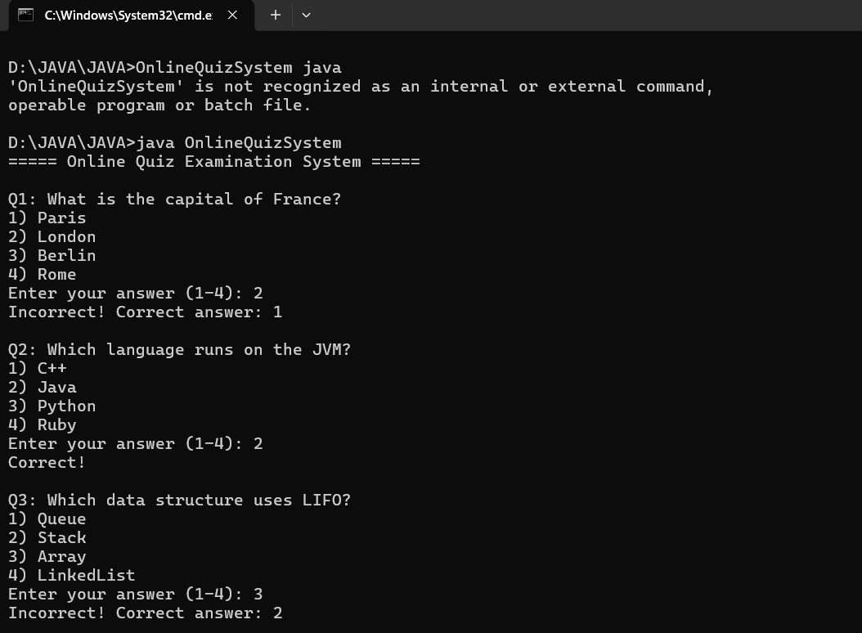

Figure 2: output

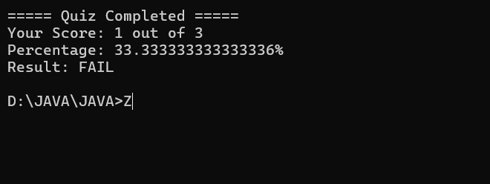

20

7.DISCUSSION & CONCLUSION

7.1 Discussion
The Online Quiz Examination System with Automated Result Evaluation modernizes traditional examinations by automating quiz creation, conduction, and evaluation. It allows instructors to design quizzes using multiple question types, store them in a centralized question bank, and generate random questions for fairness. Students can take quizzes online, receive immediate results, and access detailed performance reports to track their progress. Automated grading eliminates human error and reduces evaluation time. Features such as timed exams, secure login, and question randomization ensure integrity. Overall, the system improves efficiency, accuracy, accessibility, and reliability, providing a practical solution for contemporary educational assessment needs.

7.2 Conclusion
The Online Quiz Examination System with Automated Result Evaluation effectively modernizes the examination process by replacing traditional paper-based tests with a digital platform. This system allows instructors to create, manage, and schedule quizzes easily while supporting multiple question types and a centralized question bank. Students can take exams online, receive instant results, and access detailed performance reports, which help in identifying strengths and weaknesses. The automated evaluation feature eliminates manual grading errors and significantly reduces the time required to assess results. Security measures, including timed exams, randomized questions, and secure logins, ensure fairness and maintain the integrity of assessments. Additionally, the system improves accessibility, allowing students to participate from any location with internet connectivity. Overall, the system provides a reliable, efficient, and scalable solution for educational institutions, enhancing teaching, assessment, and learning outcomes in modern digital environments.

21
8.REFERENCES

The following resources were used during the development of this project:
Books
- Malik, P., & Sharma, A. (2019). Automated Quiz System using Java and MySQL. International Journal of Engineering Research & Technology, 8(6), 45–50.
- Tanenbaum, A. S., & Bos, H. (2015). Modern Operating Systems. Pearson Education.

Websites
https://docs.oracle.com/javase/tutorial/
https://www.w3schools.com/php/php_mysql_intro.asp
https://www.tutorialspoint.com/java/index.htm

22

